RESOLUTION NO.__________

RE: CERTIFICATE OF APPROPRIATENESS UNDER THE
PROVISIONS OF THE ACT OF THE PENNSYLVANIA
LEGISLATURE 1961, JUNE 13, P.L. 282 (53
SECTION 8004) AND BETHLEHEM ORDINANCE NO.
3952 AS AMENDED.

WHEREAS, it is proposed to install two blade signs and vinyl window signs at 520-526 Main St.

NOW, THEREFORE, BE IT RESOLVED by the Council of the City of Bethlehem that a Certificate of Appropriateness is hereby granted for the proposal.

Sponsored by: (s)

(s)

ADOPTED BY COUNCIL THIS DAY OF

(s)
President of Council

ATTEST:

(s)
City Clerk

HISTORICAL & ARCHITECTURAL REVIEW BOARD

The applicant is proposing to install two blade signs and vinyl window signs at 520-526 Main St.
APPLICATION #3:

David Klein Real Estate
520-526 Main St.
Bethlehem, PA 18018

518 Main St.
Bethlehem, PA 18018

OWNER:

__________________________________________________________________________

The Board upon motion by Marsha Fritz and seconded by Gen Marcon adopted the proposal that City Council issue a Certificate of Appropriateness for the following:

- There will be two stores on the ground floor and will have blade signs and vinyl lettering.

2. The left unit will have a blade sign on an existing bracket for URBANO Mexican
Kitchen and Bar. Background will be a warm concrete color compatible with the
Granite panels. Lettering to be black.

3. Vinyl window signs to be brass in color.

4. Signs for the right side will consist of a new blade sign with bracket mounted in
mortar joints. Background color and lettering to be a light cork color.

5. Each blade sign is to have a pin stripe.

6. The motion was unanimously approved.

__________________________________________________________________________

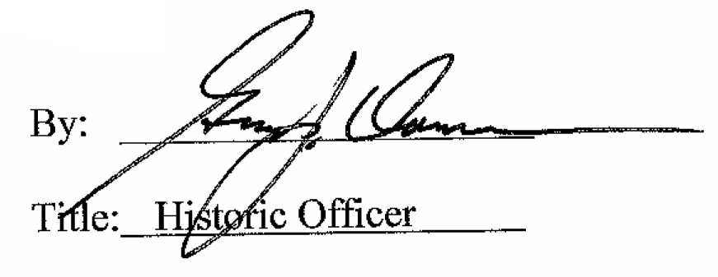

Date of Meeting: January 3, 2018

